Map function

* F is applied to each element in the list

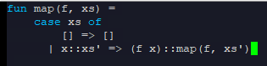

Using the map function



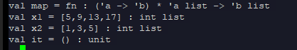

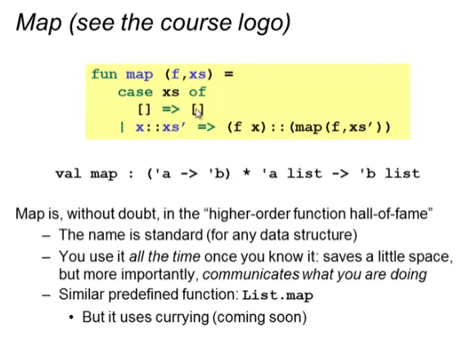

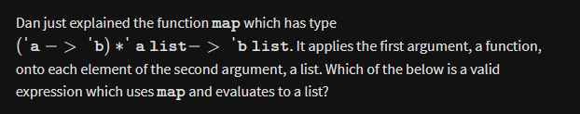

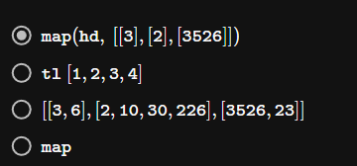

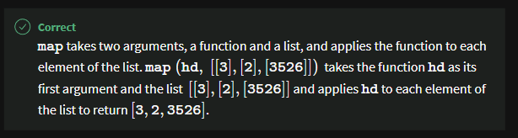

Filter function

* f arg returns bool
* Filter returns a subset of the passed list for which “f” returns true

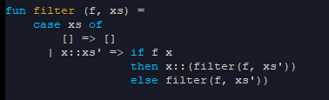

Using filter function

